**Main text figures:**

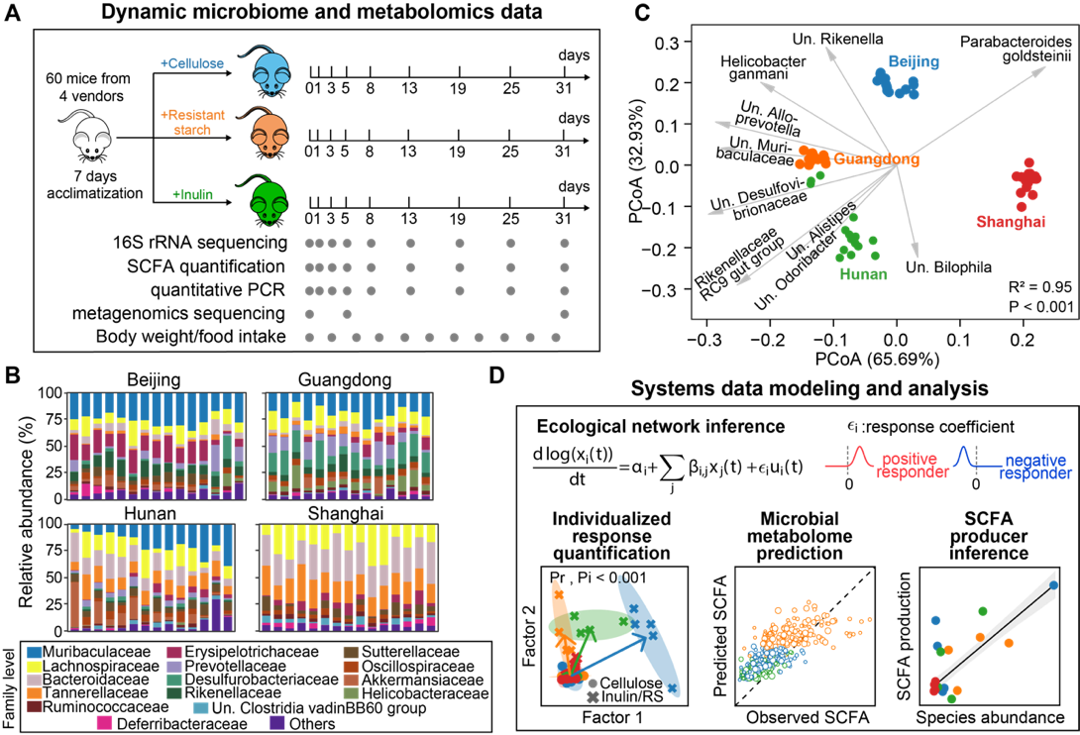

**Figure 1.** **Experimental design and computational framework to study the dynamic and individualized response of mouse gut microbiome to dietary fiber intervention. A.** A schematic view of the experiments performed on a mouse model. Gray dots indicate the days on which longitudinal fecal samples, microbiome and metabolomics data were collected. SCFA: short-chain fatty acid. **B.** Baseline gut microbiota composition of isogenic mice purchased from four different vendors. **C.** PCoA (principal coordinate analysis) biplot of the baseline microbiota in penal **B**. Dots represent baseline samples and gray arrows represent dominant bacterial species in the samples. The sample whose dot projects furthest in the direction of a species has the highest relative abundance of that species. R2 and P-value were obtained from Adonis analysis, which tests for baseline differences across the four vendors. **D.** An illustrative overview of our systems biology approaches for data analysis. We used ecological modeling to infer key dietary fiber responders, time series factor analysis to visualize and test statistical significance of individualized responses of both microbiome and SCFA (two P-values: Pr for responsiveness and Pi for individuality), and machine learning models to predict SCFA concentration from microbiome predictors and infer SCFA producers.

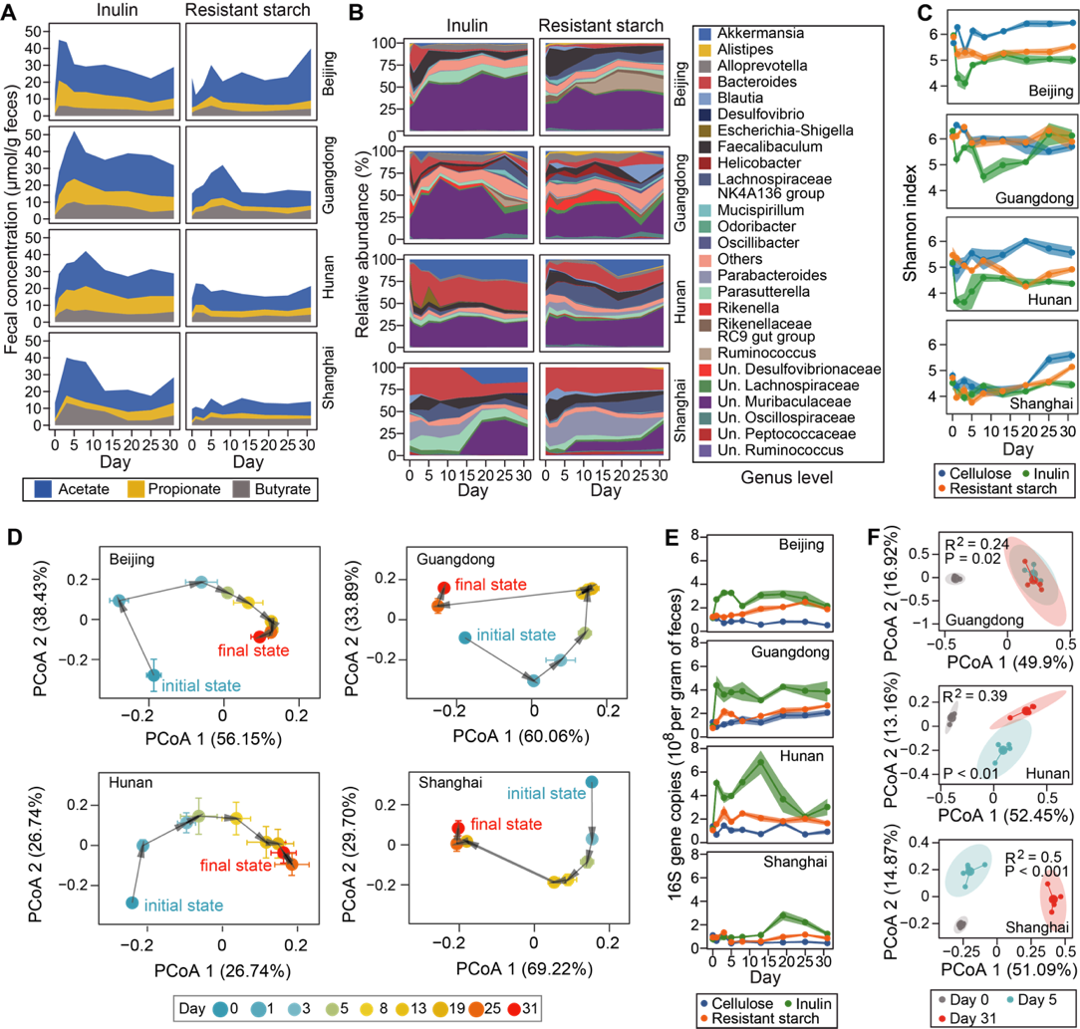

**Figure 2.** **Dynamical responses of short-chain fatty acid (SCFA) metabolism and gut microbiome to dietary fiber intervention. A**-**C.** Temporal changes in fecal concentration of three major SCFAs (A), microbiota composition (B), and its compositional alpha diversity (C) within four weeks’ intervention of two dietary fibers (inulin and resistant starch). Both SCFA concentration and microbiota diversity show short-term overshoot and long-term steady-state responses to inulin treatment. **D.** The averaged response trajectories of gut microbiota to inulin, as shown in PCoA (principal coordinate analysis) ordination scatter plot, also indicate compositional transition and convergence to different steady states from the baseline. **E**. Total bacterial density measured by quantitative PCR. **F**. PCoA ordination scatter plot of gene abundances in inulin-treated mice metagenome. R2 and P-value were obtained from Adonis analysis, which tests for gene abundance differences among different response phases (day 0 for baseline, day 5 for short-term and, day 31 for long-term). For panels A and B, the heights of stacked bands represent averages across individual mouse. For **C-E**, lines or dots represent mean values and shading areas or error bars represent standard error of the mean.

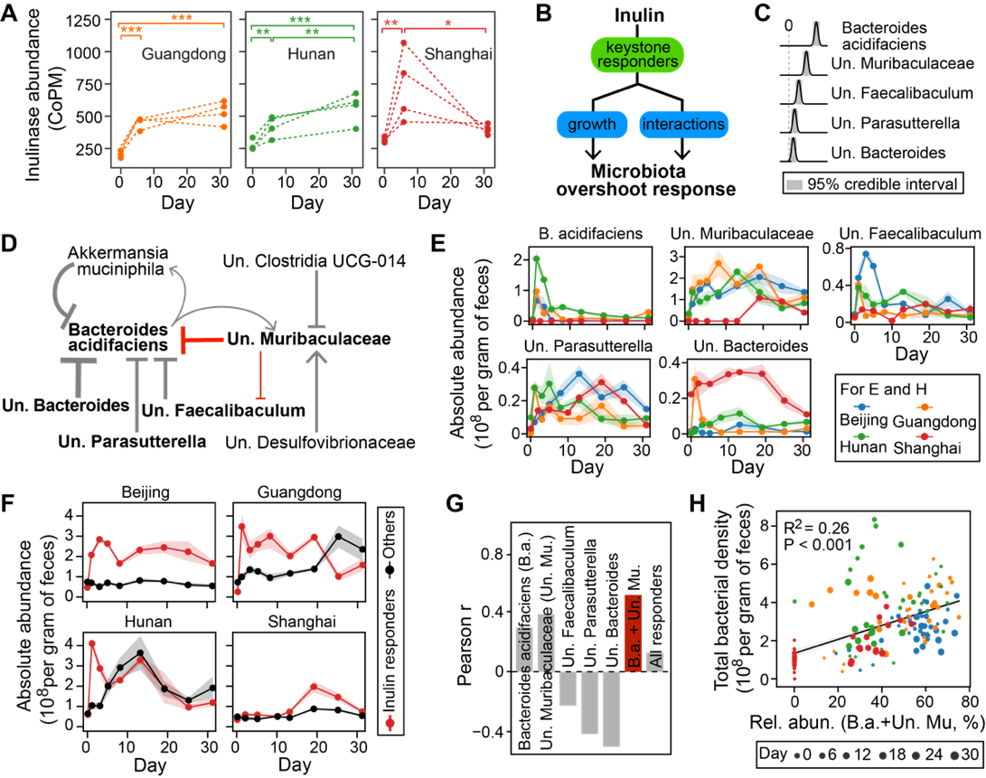

**Figure 3. Microbiota dynamics in response to inulin is driven by several key** **responders****. A.** Increased expression of inulinase genes following inulin treatment. Each dotted line represents an individual mouse. *: P < 0.05; **: P < 0.01; ***: P < 0.001. **B-F**. Inference of inulin responders and associated ecological interactions. **B.** A schematic diagram showing our hypothesis that the observed overshoot dynamic responses of gut microbiota to inulin are predominately determined by growth and ecological interactions of key responder species. **C.** Posterior distribution of five bacterial species with significant growth responses. **D.** Core ecological interaction network constituted by significant interspecific interactions (self-interactions not shown). Point and blunt arrows represent positive and negative interactions respectively. The arrow thickness is proportional to the posterior mean of the corresponding interaction coefficient. For C and D, significance was determined when 95% credible interval does not include 0. **E.** Absolute abundance of the five inulin responders shown in panel C. **F**. Comparison of total absolute abundance between inulin responders and other bacterial species. The inulin responders together dominate the short-term responses of gut microbiota. **G**,**H.** Prediction of total bacterial density (i.e., absolute abundance) from relative abundance of inulin responders. **G**. Pearson correlation for different combinations of inulin responders. The red bar has the highest correlation coefficient. **H**. Scatter plot showing the positive correlation of the combined relative abundance of Bacteroides acidifaciens (B.a.) and unclassified Muribaculaceae (Un. Mu.) with total bacterial density. Gray line: linear regression (R2 and P-value are indicated in the plot); shading area: standard error of the regression.

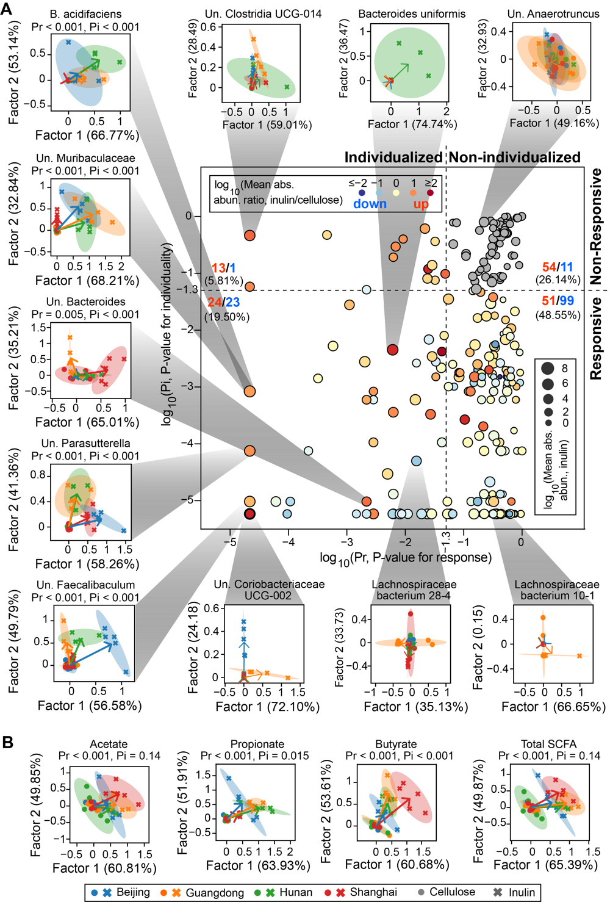

**Figure 4.** **Visualization and quantitative significance test of individualized responses of bacterial species (A) and short-chain fatty acids (SCFAs) (B) to inulin supplement.** The scatter plot in panel A distinguishes four different scenarios of individualized responses depending on the P-values for significance test of responsiveness (Pr) and individuality (Pi). The bacterial species whose responses to inulin are both non-responsive and non-individualized are marked as gray dots, which are otherwise colored by the ratio of their averaged absolute abundances (abs. abun.) between inulin and cellulose group. We displayed the inulin-stimulated longitudinal responses of bacterial species and SCFAs, relative to their corresponding responses in the cellulose group, in a reduced two-dimensional (2D) space spanned by factor 1 and factor 2 extracted using sequential non-negative matrix factorization (see Methods for details). In the 2D visualizations, each symbol represents a mouse (dots: cellulose group, crosses: inulin group) and all mice data from the same vendor under the same dietary fiber treatment was used to fit an eclipse. For each vendor, an arrow was drawn from the eclipse center of the vendor under cellulose treatment (standardized to the origin) to that under the inulin treatment. Numbers in parentheses indicate factor loadings.

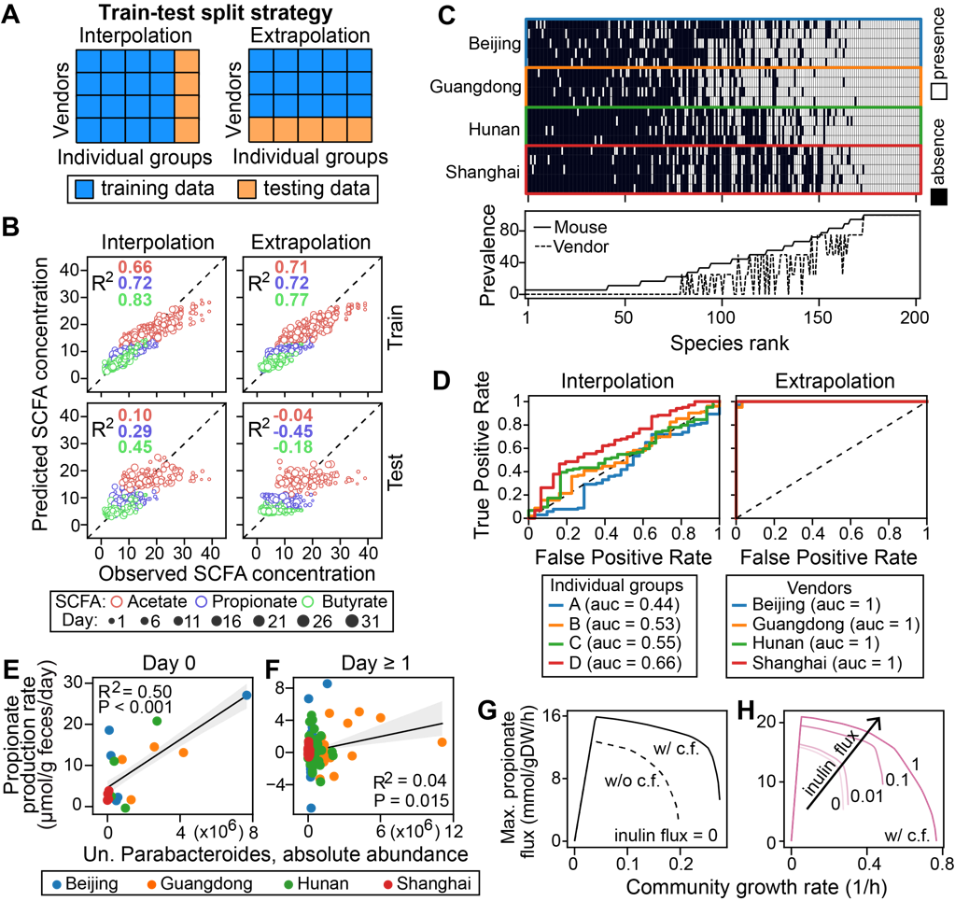

**Figure 5.** **Robust learning of microbiome-metabolome relationship** **is** **constrained by covariant shift. A**,**B.** Learning microbiome-metabolome relationships using machine learning models. **A**. Two data-splitting strategies for testing model performance. Mice in the testing sets were randomly selected on a one-per-vendor basis for “interpolation” and exclusively selected from a single vendor for “extrapolation”. **B**.Training and testing accuracy in Random Forest regression models trained on absolute abundance of bacterial species. Data in day 0 were removed from the analysis. **C**,**D**. Covariant shift in cross-validation. **C**. Presence (threshold: 0.001%) and prevalence of bacterial species in baseline microbiota across mice and vendors. Species absent in any mouse baseline sample were not shown. The prevalence score of a species across mice was defined as the fraction of mice that contains this species in their baseline microbiota and that across vendors was the fraction of vendors whose mice all contain this species. **D**. Receiver operating characteristic (ROC) curve analysis of the similarity between training and testing datasets. A Random Forest classifier trained to discriminate the two datasets outputs area under the ROC curve (auc) as a similarity score (see Methods for details). **E**-**H**. Potential producers and cross-feeding relationships for propionate production. **E**,**F**. Correlation of baseline unclassified (Un.) Parabacteroides absolute abundance with initial propionate production rates on day 0 (E) and rates in later days (F). Gray line: linear regression (R2 and P-value are indicated in the plot); shading area: standard error of the regression. **G**,**H**. Simulated effects of cross-feeding (c.f.) (G) and inulin availability (H) on growth and propionate flux of two-genera Bacteroides-Parabacteroides community. w/ c.f.: mixing Bacteroides and Parabacteroides in 1:1 ratio; w/o c.f.: mixing Parabacteroides and its clone mate in 1:1 ratio.

**Supplementary figures:**

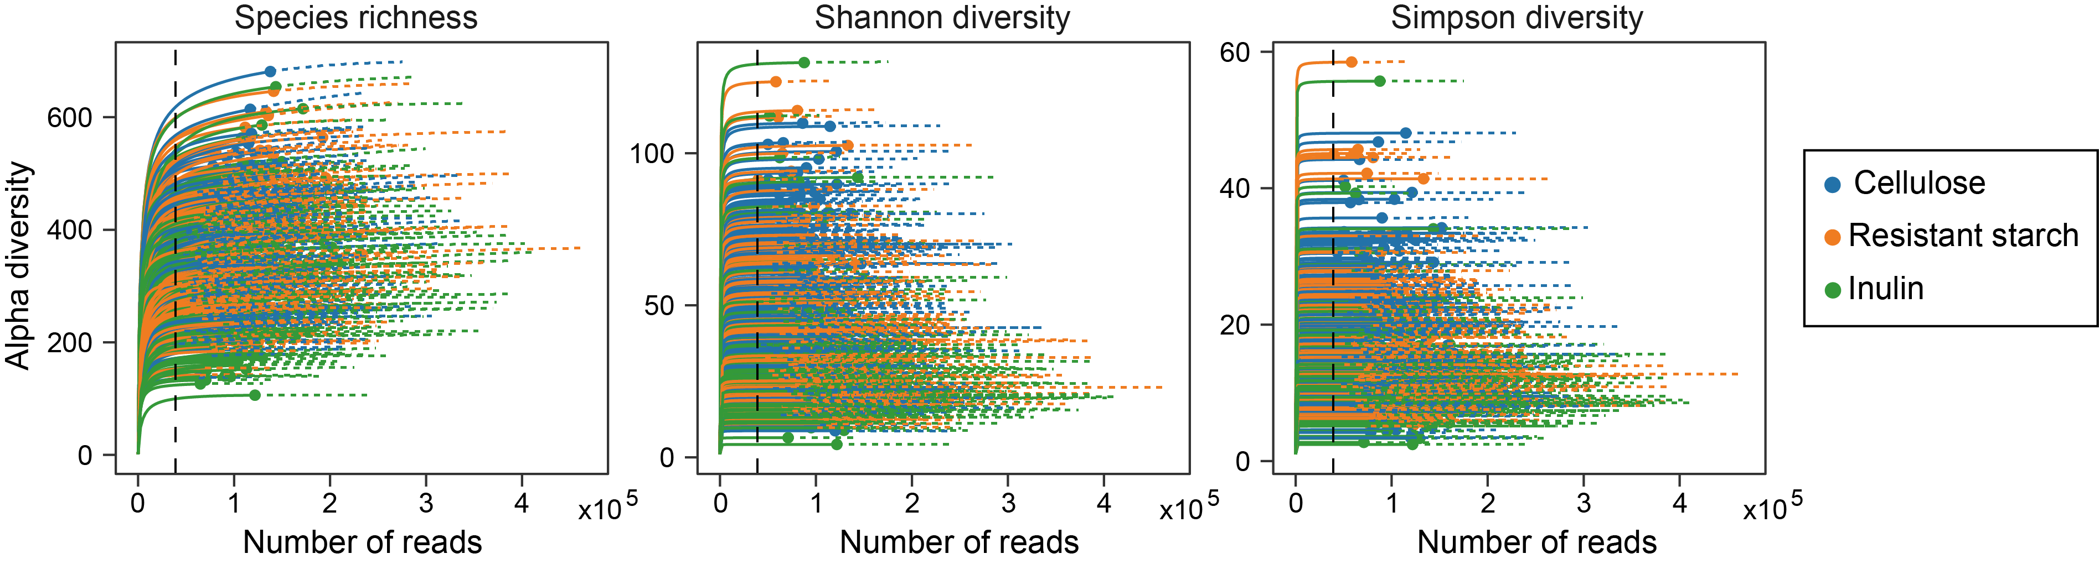

**Figure S1. Rarefaction analysis of 16S rRNA gene clone libraries in terms of species richness, Shannon diversity, and Simpson diversity.** Rarefaction curves were generated using the iNEXT package. Solid lines represent the observed alpha diversity with the number of reads sampled, and dashed lines represent the extrapolation of the solid lines until 25% more reads. To avoid sample-to-sample bias due to variable sequencing depth (different number of reads per sample), all samples were rarefied to 38,980 sequences (black dashed line) per sample before downstream analysis.

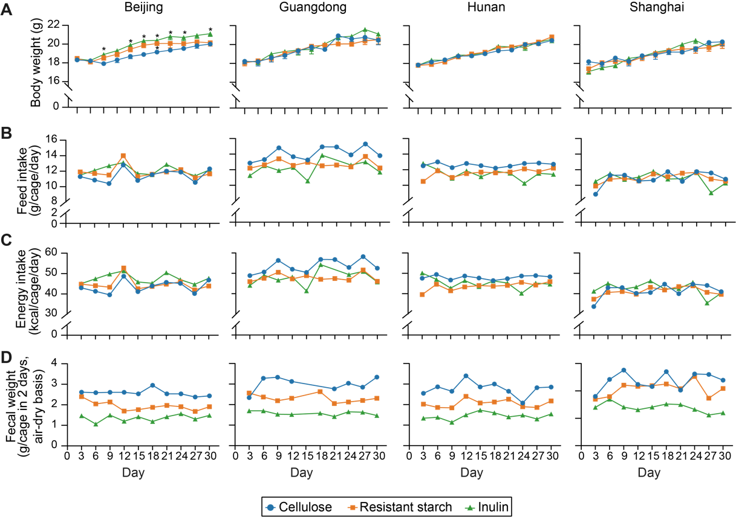

**Figure S2. Effects of inulin or resistant starch on (A) body weight, (B) daily food intake, (C) daily energy intake, and (D) 48-hr fecal sample weight of mice receiving diet supplementation used in this study.** Each symbol represents the mean body weight in panel A or a single data point in panels B-D. The body weight data were analyzed by ordinary one-way ANOVA with Turkey post hoc test between inulin or resistant starch and cellulose group. *, P < 0.05.

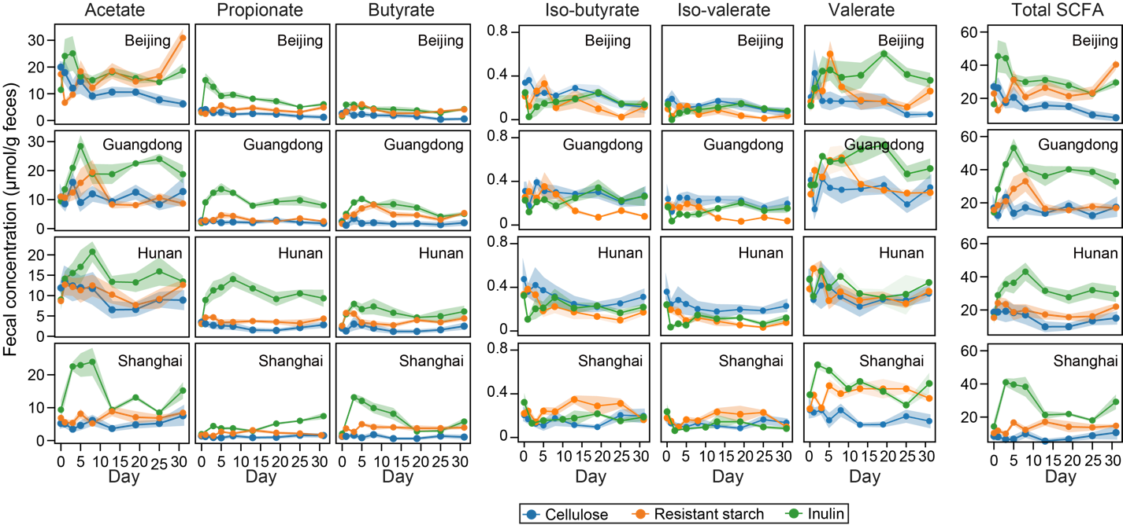

**Figure S3. Dynamics of fecal short-chain fatty acid (SCFA) concentration following dietary fiber intervention.** Lines represent mean concentrations and shading areas represent standard error of the mean.

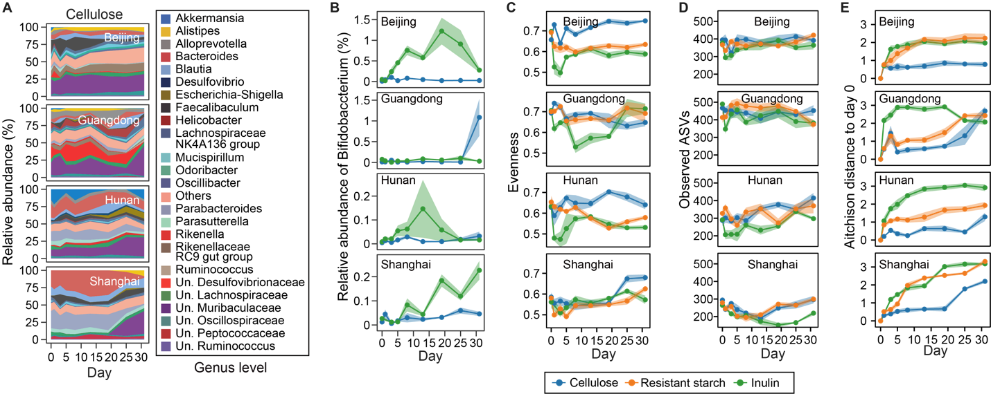

**Figure S4. Dynamics of cellulose-group microbiota composition (A), relative abundance of the genus Bifidobacterium (B), evenness (C), number of observed ASVs (D) and beta diversity (E) following dietary fiber intervention.** For panels B-E, Lines represent mean values and shading areas represent standard error of the mean. Beta diversity was calculated based on Aitchison’s distance after pairing using the “first distances” method.

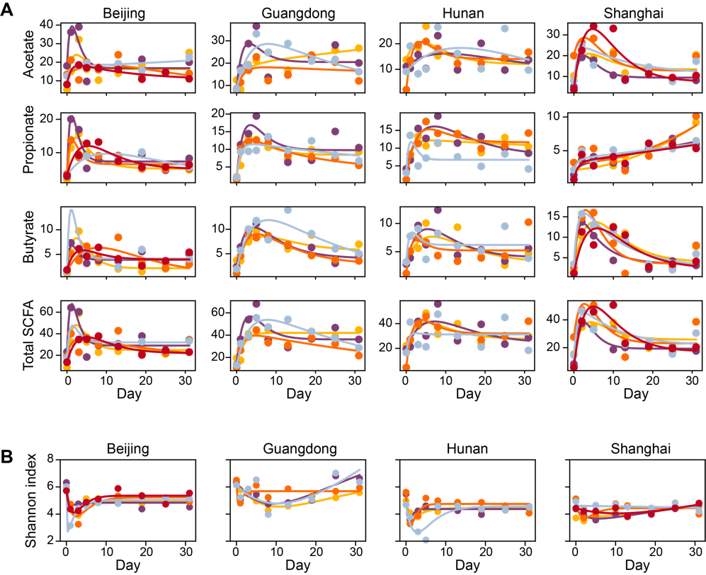

**Figure S5. Fitting a harmonic oscillator model to the dynamics of short-chain fatty acids (A) and Shannon diversity (B).** Dots represent data and lines represent simulations using the best-fit parameter values. Both lines and dots are color-coded on a per-mouse basis.

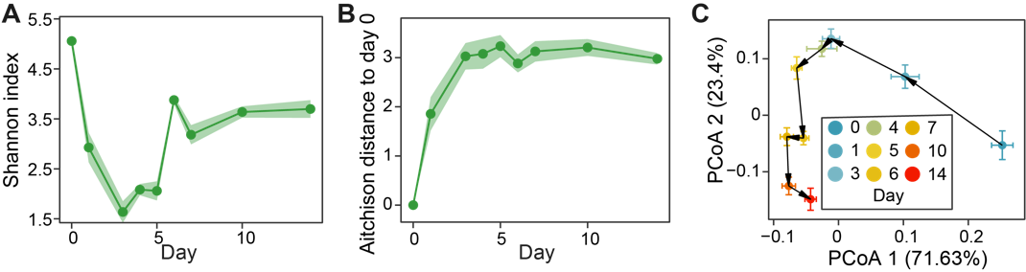

**Figure S6. Reanalysis of data from Chijiwa et al., 2020, where** **a similar experiment was performed to observe the gut microbiota dynamics following inulin treatment in a mouse model.** **A**. Alpha diversity. **B**. Beta diversity (Aitchison’s distance after pairing using the “first distances” method). **C**. The averaged response trajectory of gut microbiota in PCoA (principal coordinate analysis) ordination scatter plot. Each dot represents the mean principal coordinate score of all mice and the corresponding error bar represents the standard error of the mean.

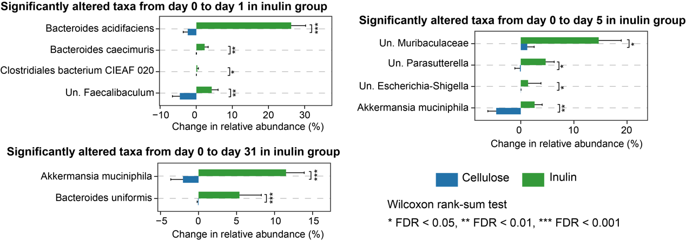

**Figure S7.** **Significantly altered bacterial species in relative abundance between inulin and cellulose groups.** The identified species vary depending on the day of observation.

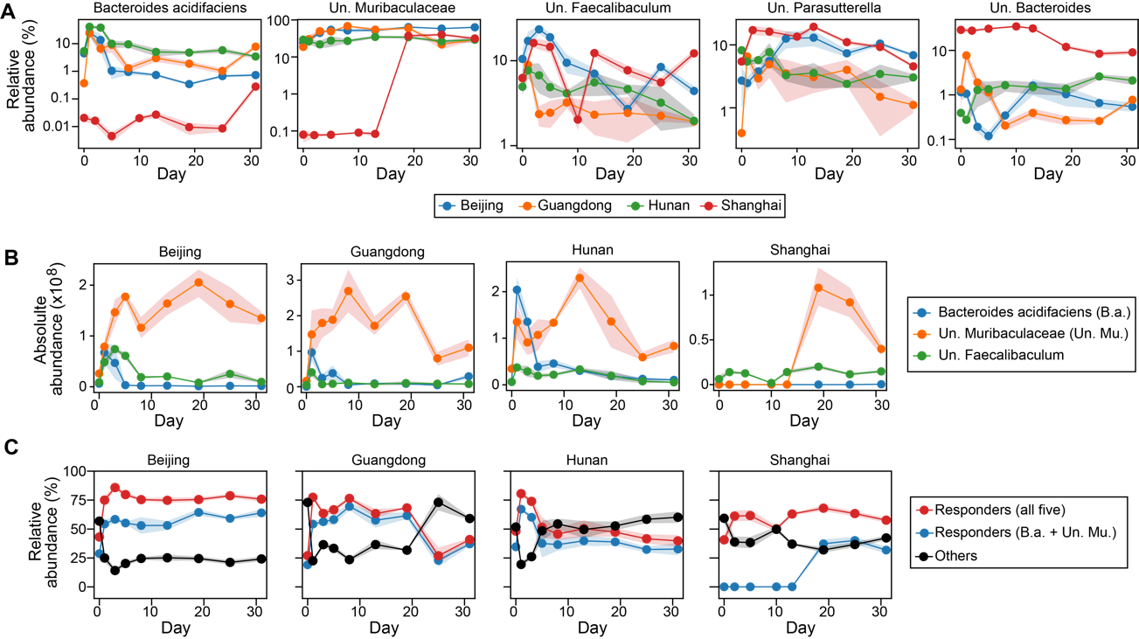

**Figure S8. Dynamics of inulin responders.** **A**. Relative abundance of each inulin responder inferred from ecological network model. **B**. Three responders that might compete for inulin (see the main text Fig. 3D for inferred interspecific interactions). **C**. Comparison of total relative abundance between inulin responders and other bacterial species.

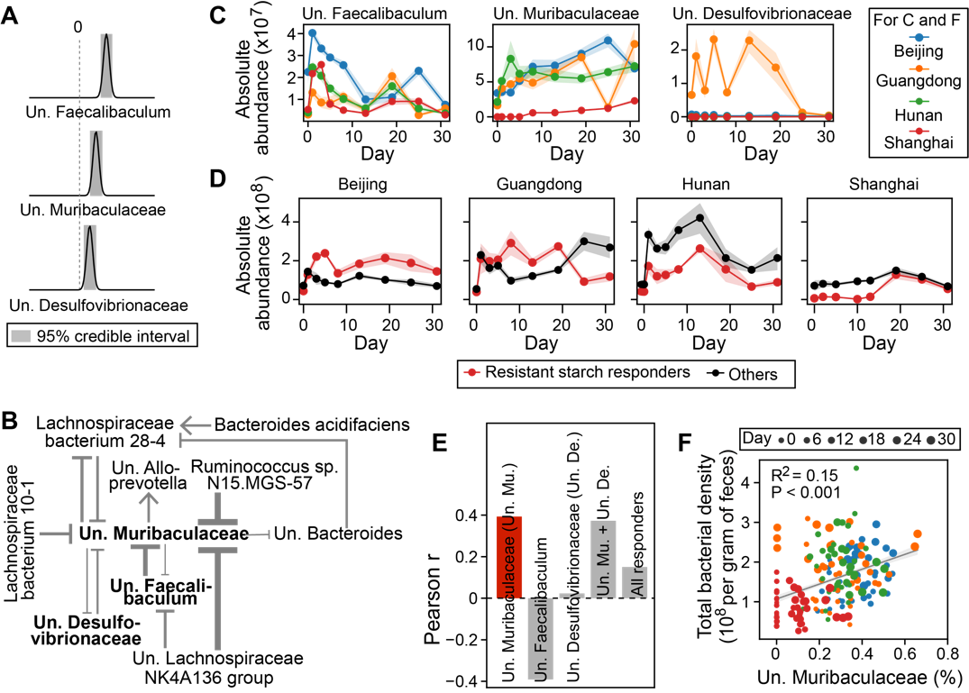

**Figure S9. Inferring bacterial responders to resistant starch intervention and associated ecological interaction network.** The same figure legend applies as in the main text Fig. 3C-H (the same order).

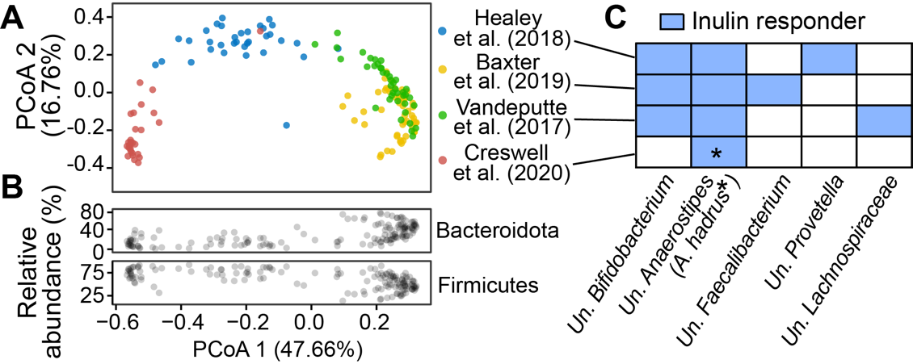

**Figure S10. Inference of inulin responders in human gut microbiome. A.** Principal coordinate analysis (PCoA) of baseline human gut microbiota (Bray-Curtis distance matrix of 16S or shallow shotgun metagenomics) in four cohorts of literature studies with inulin intervention. **B.** Relative abundance of two major bacterial phyla in the same samples shown in panel A. **C.** Positive inulin responders identified from the four literature studies in panel A. We used the same generalized Lotka-Volterra model and Bayesian inference framework as we used for our mouse experiments (see Methods in the main text for details).

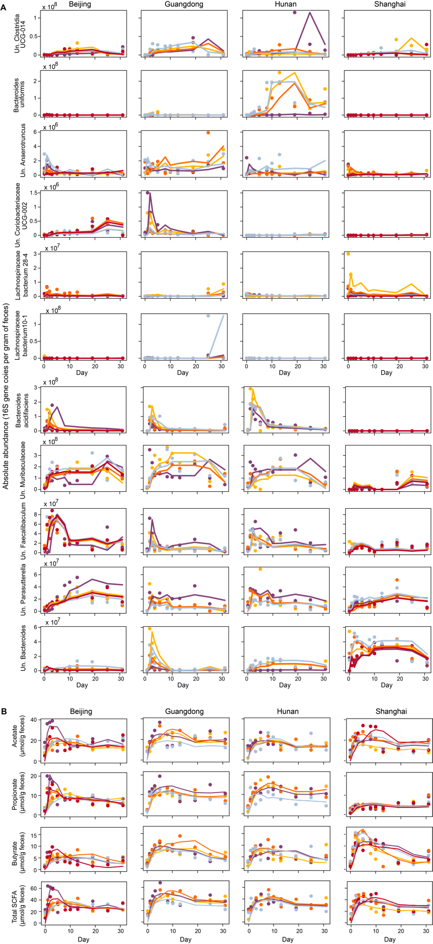

**Figure S11. Reconstructed time series (lines) of selected bacterial species (A) and short-chain fatty acids (B) in the main text Fig. 4 using the first two factors of sequential Non-negative matrix factorization.** Dots represent observations and both lines and dots are color-coded on a per-mouse basis.

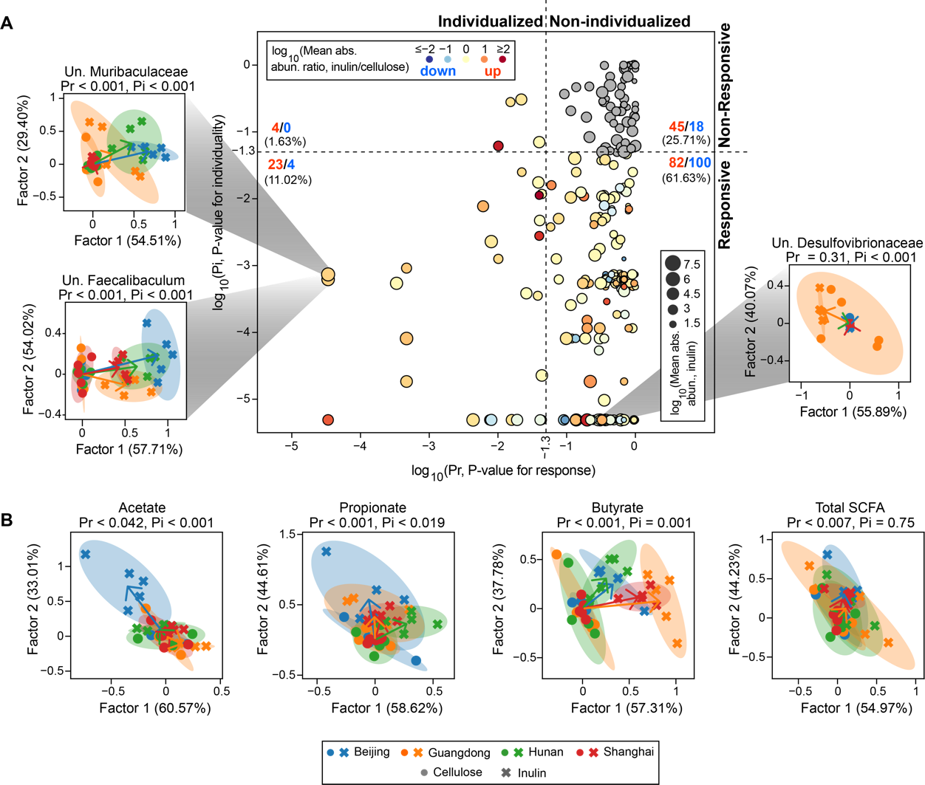

**Figure S12. Individualized response analysis of bacterial species (A) and short-chain fatty acids (B) for resistant starch intervention.** The same figure legend applies as in the main text Fig. 4.

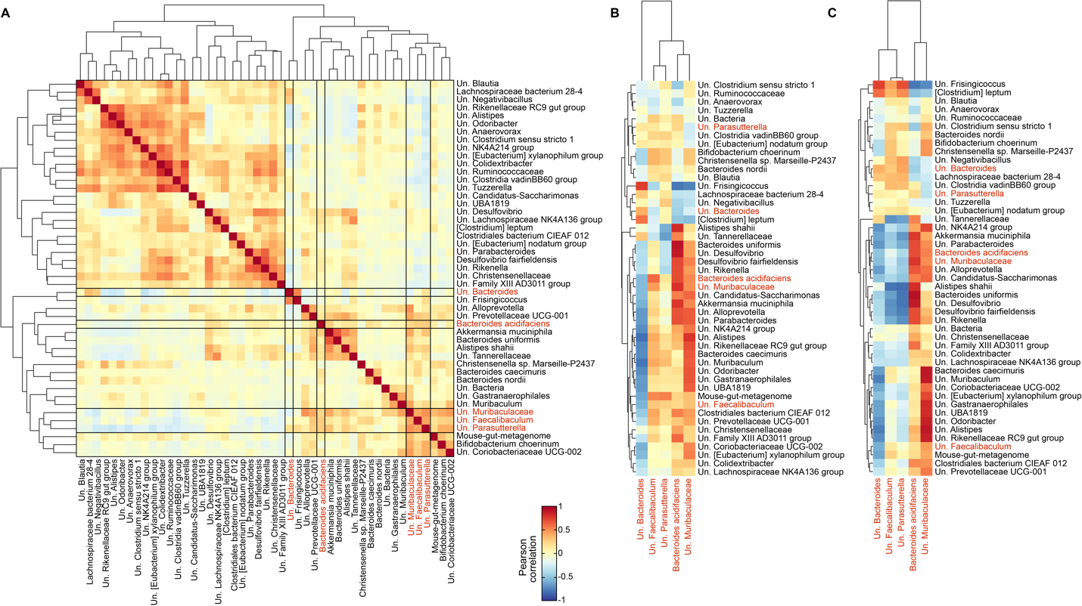

**Figure S13. Pearson correlation between species with significant individualized responses (identified in the main text Fig. 4A) and inulin responders (highlighted in red). A**. Correlations were performed using absolute abundances of bacterial species at all time points. **B**,**C**. Correlations were performed between baseline absolute (B) or relative (C) abundances for species with significant individualized responses and total area under the curve of absolute abundances for inulin responders.

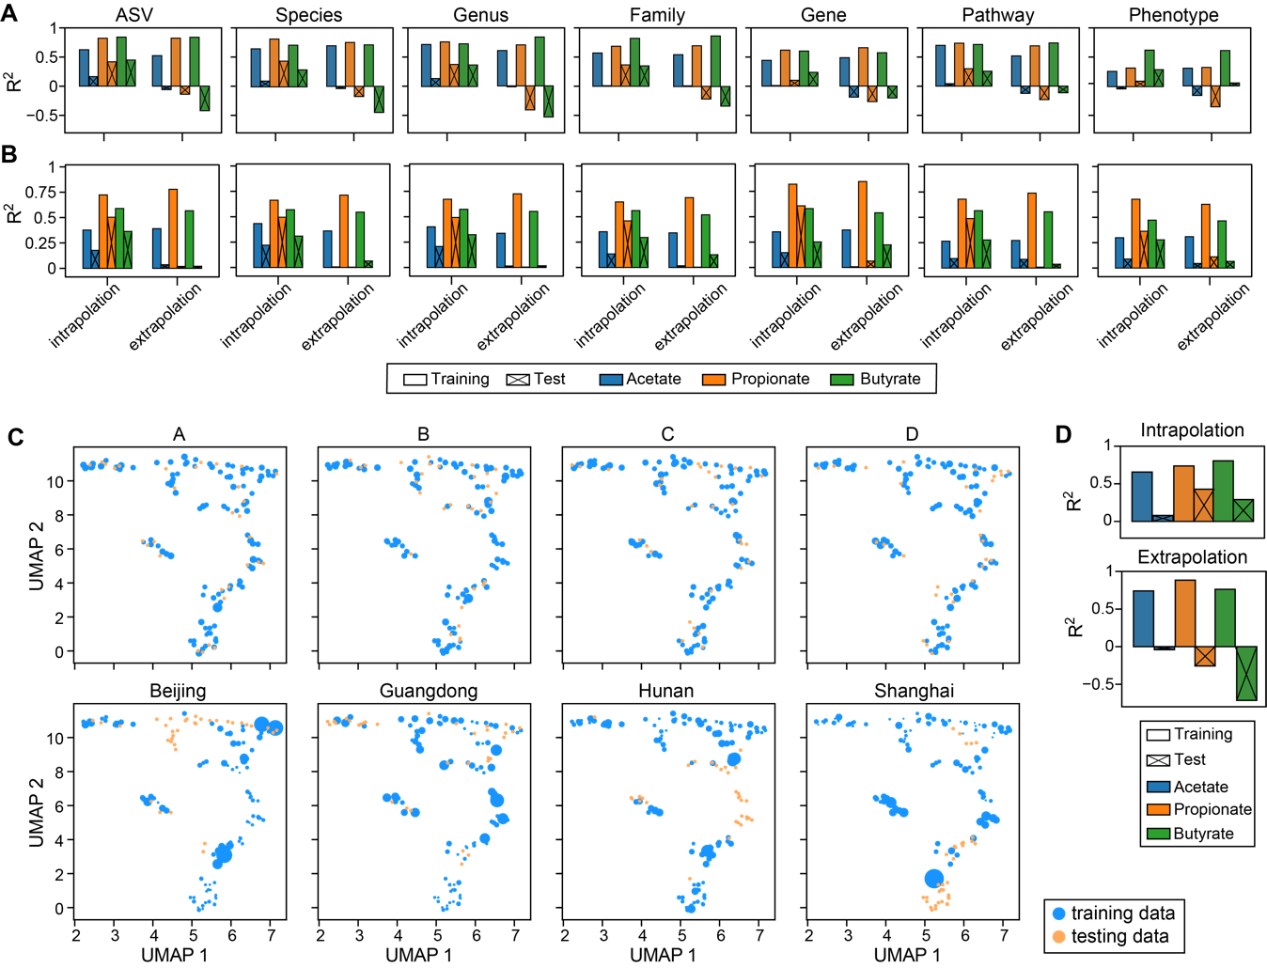

**Figure S14. Poor performance of random forest model in predicting short-chain fatty acids (SCFAs) concentration (see Fig. 5B of the main text for results) cannot be rescued by using (A) alternative predictors, (B) alternative regression models, and (C,D) weighting of training samples. A**. Prediction accuracy using random forest regression model and taxonomic (ASV, Species, Genus, Family) or functional (Gene, Pathway, Phenotype) representation of gut microbiota as predictors. The abundances of genes, pathways and phenotypes were predicted using PICRUSt2. **B**. Prediction accuracy using MelonnPan and the same predictors as used in panel A. **C**. Sample weights under different data-splitting strategies. The weights of training samples closer to their corresponding test samples were assigned higher values, as indicated by larger circle sizes in a reduced two-dimensional UMAP (Uniform Manifold Approximation and Projection) space.The sample weight was calculated as 1/Pi-1, where Pi is the probability of sample i belonging to the training distribution and was estimated using random forest classifier (the same approach was applied to generate Receiver Operating Characteristics curves in Fig. 5D of the main text; see Methods in the main text for details). **D**. Prediction accuracy using random forest regression model built from weighted training data and absolute abundances of bacterial species as predictors.

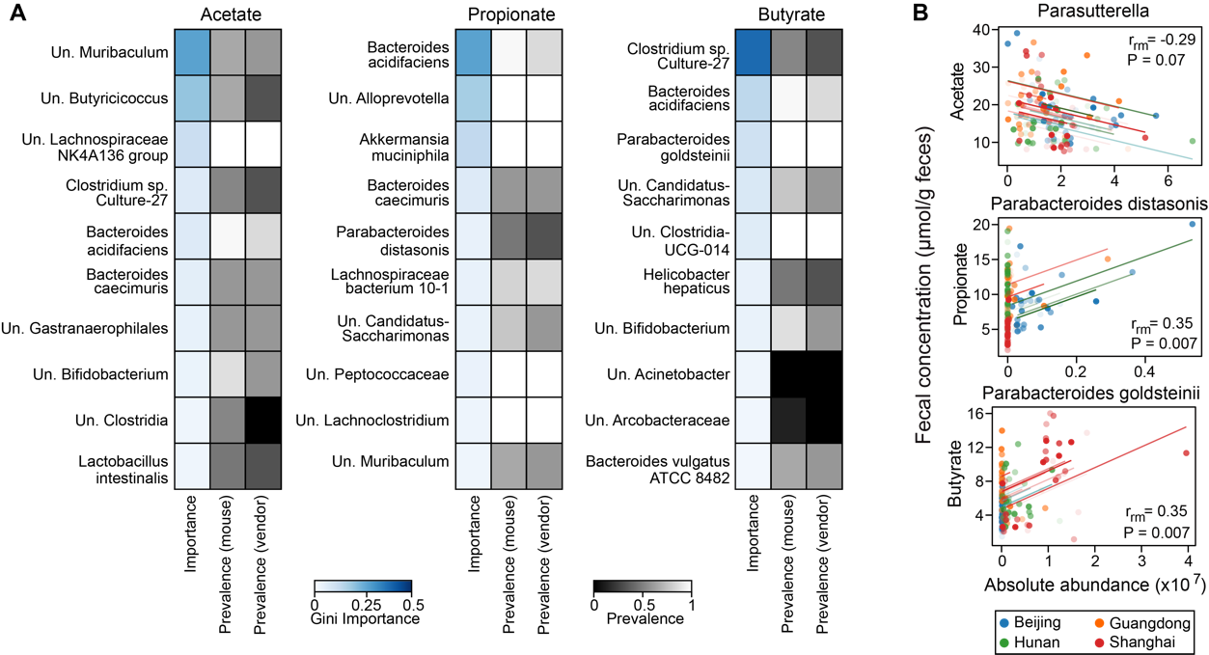

**Figure S15. Inferred short-chain fatty acid (SCFA) producers in inulin-treated mice vary depending on the inference approaches. A.** Random forest (RF) regression. For each SCFA, we showed top 10 bacterial species with the highest Gini importance score in model training using all data. The absolute abundances of bacterial species were standardized and filtered (threshold 10-5) by LASSO (least absolute shrinkage and selection operator) regression before passing to RF model. Several key hyperparameters in LASSO and RF were optimized using grid search cross-validation with R2 as the score metric. The prevalence scores were obtained from Fig. 5C in the main text. **B**. Repeated correlation analysis. Longitudinal data and correlation trend lines are color-coded on a per-mouse basis. Repeated measures correlation coefficients (*r*rm) and FDR-corrected P-values are indicated in the plot.

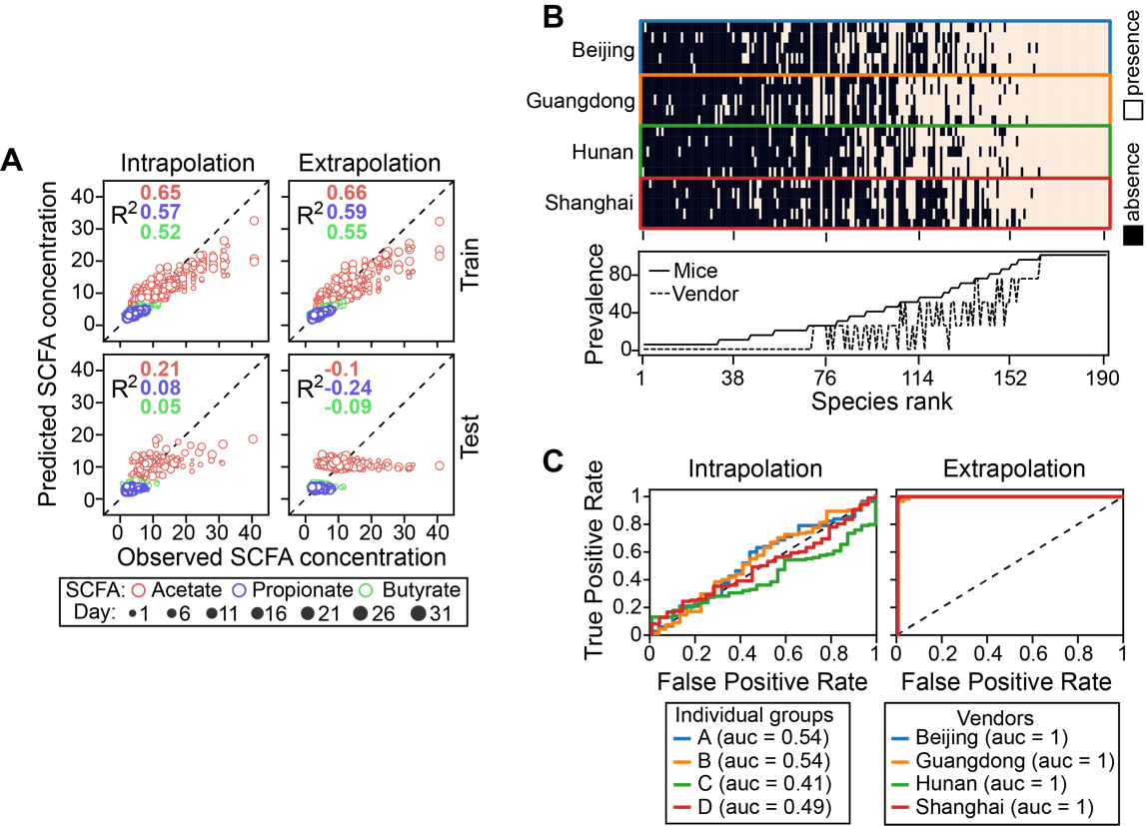

**Figure S16. Prediction of short-chain fatty acid (SCFA) concentration from gut microbiota using data from resistant starch-treated mice**. The same figure legend applies as in the main text Fig. 5B-D (the same order).

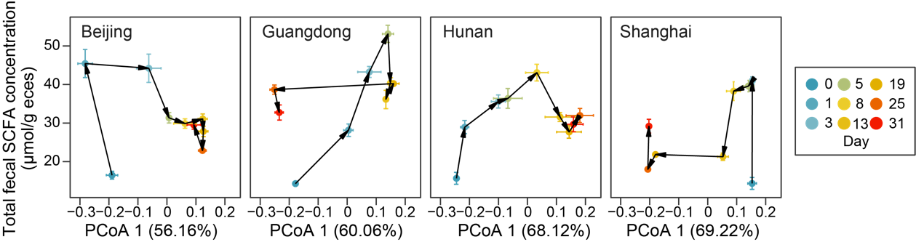

**Figure S17**. **Dynamic relationship between gut microbiota composition (x-axis) and total SCFA concentration (y-axis)**. We used the first principal coordinate score from PCoA (principal coordinate analysis) ordination to represent changes in gut microbiota composition (relative abundance) along the direction of maximum variance. Except for Guangdong mice, the first PCoA scores only change slightly between day 0 and day 1. Points represent the mean PCoA scores across mice in each vendor and error bars represent the standard error of the mean.